Using prompts to generate an image:
Output:
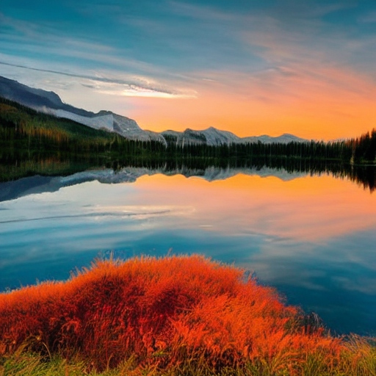

The above image has been created using deepai.org. Use the above image and create a similar image by making use of AI.
Here are some words you can use when prompting: Sunset, River, Mountain, Nature.

